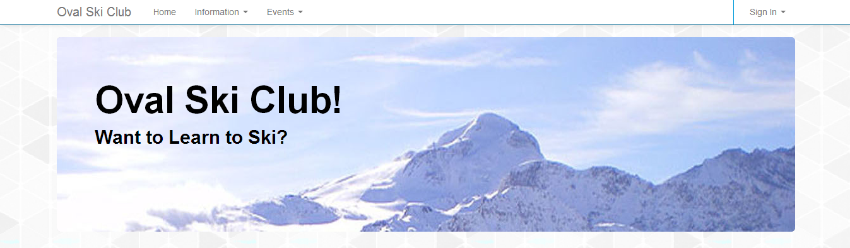

Sign In

Dropdown 2

Dropdown 1

Home

Oval Ski Club

Hero Unit

HEADING

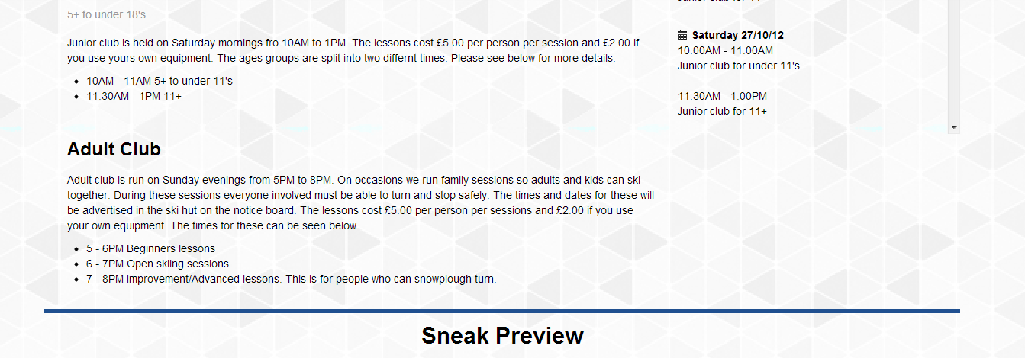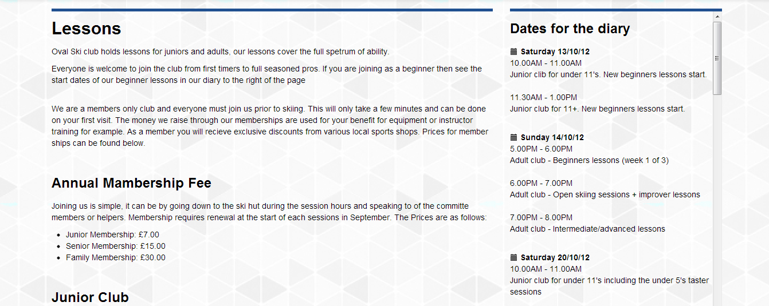

HEADING

YouTube video

TEXT – Diary scrollable

TEXT

HEADING

Sign in is a drop down login form

Dropdown2 links to:

* Social.html
* RacingTeam.html
* Sessions.html

Dropdown1 links to:

* AboutUs.html
* ContactUs.html
* FAQs.html

Footer & Facebook Link